Elizabeth Hawkins

CIS-245 Linux administration

Documentation for sed

September 27, 2021

1. Change the name Meg to Megan

sed s/Meg/Megan/ datebook is the command you use to change the name Meg to Megan. s is the substitution operation, / is used to delimit regular expressions. Meg is the search pattern, and Megan is the name you want to be replaced with Meg. As you can see when I run the command it is now Megan Murry instead of Meg Murry.

1. Delete the last 3 lines

sed ’48,$ d’ is the command I used to delete the last 3 lines. 48 will let you know that is the line you want to start, $ is the end of the file and d is for delete so you are deleting all lines from 48 and beyond.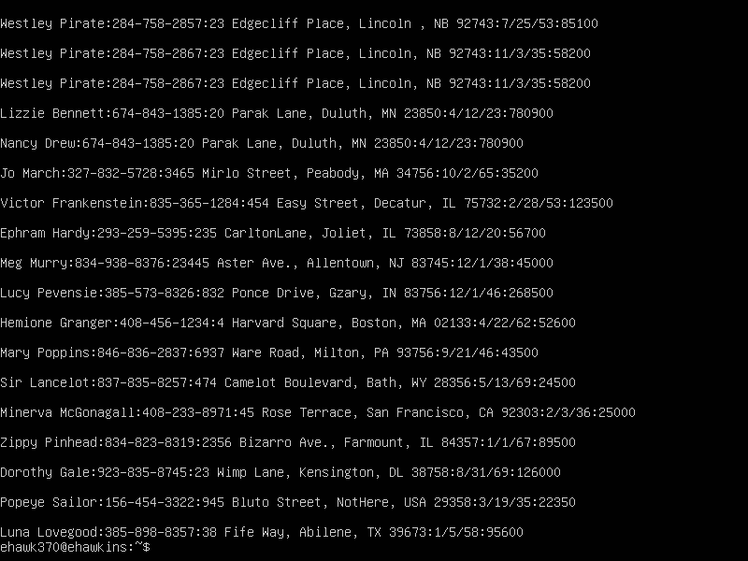

1. Print lines 2 through 4

sed -n 2,4p datebook2 is the command I used to Prints lines 2 through 4.

-n suppresses automatic printing of pattern space 2 is the line you want to start at and will be the first to be printed. , represents the number you want to go through. 4 is where the line would stop. Seeing that the file has blank lines it only sed’s out the second line. To print all lines 2 through four I used sed -n 2,7p and it gave me the lines 2 through 4.

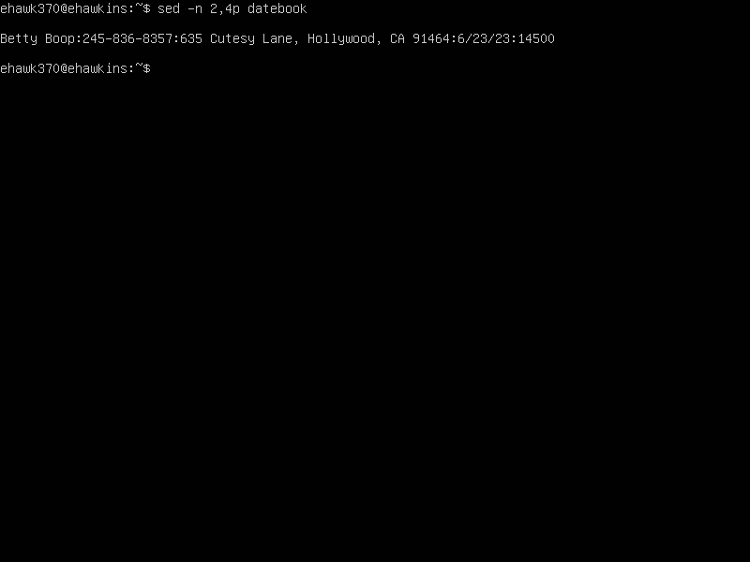

1. Delete lines containing Place

sed /Place/d datebook is the command you use to delete lines containing Place. / is used to delimit regular expression. Place is the name you’re searching for to delete d is for delete. When I ran the command, it worked as you can see it deleted all the lines containing Place.Text

1. Append three asterisks to the end of the line starting with Sir

sed -e ‘/^Sir/a\asterisks asterisks asterisks’ datebook is the command I used to append three asterisks to the end of lines starting with Sir

-e executes the command ^Sir is the beginning of the file Sir /a means append to end of the file asterisks asterisks asterisks is what you want to append at the end of the file.

1. Replace the line containing “Westley Pirate” with the phrase “As you wish”

sed ‘s/.*Westley Pirate.*/As you wish/g’ datebook is the command I used to replaces the line containing Westly Pirate with the phrase “As you wish”

s is substitution /.*Westley Pirate.* is the name you’re searching for /“As you wish” is what “Westley Pirate” is be changed to /g is global.

1. Change Minerva McGonagall’s birthday to 12/25/1960

sed ‘/Minerva McGonagall/s,[0-9]\+/[0-9]\+/[0-9]\+,12/25/1960,’ datebook is the command that changes Minerva McGonagall’s birthday to 12/25/1960

Minerva McGonagall/s is the name we are searching for [0-9]\+/[0-9]\+/[0-9] is the month,day,and year since you do not know Minerva McGonagall’s birthday \+, 12/25/1960 is the month, day, and year you are going to change Minerva McGonagall’s birthday to. When I ran the command, it changed Minerva McGonagall’s birthday to 12/25/1960.

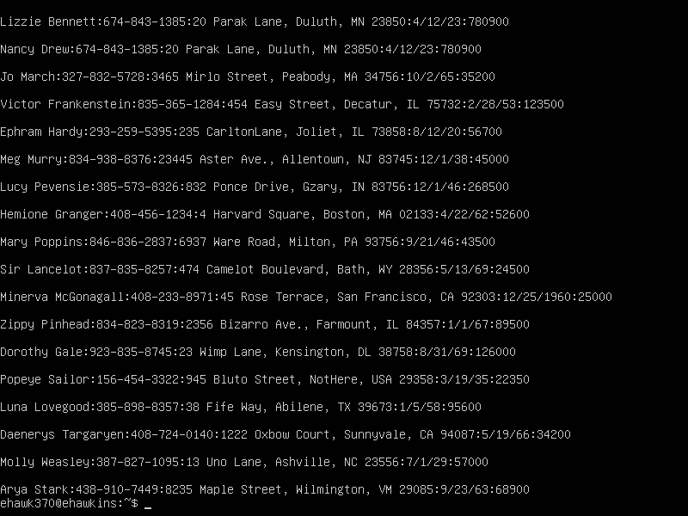

1. Delete all blank lines

sed ‘/^$/d’ datebook is the command I used to delete all blank lines.

^ is the start of the line, $ is the end of the line and d deletes. When I ran the command, it deleted all the blank lines.

1. Write a Sed script that will
2. Insert above the first line the title -Great Literary Characters-
3. Remove the duplicate lines
4. Print the contents of the file with the first name then the phone numbers
5. Append at the end of the file “Happily Ever after. The End”

#!/bin/bash

# Insert above the first line the title Great Literary Characters

sed -i ‘1i\Great Literary Characters/’ datebook

#Remove the duplicate lines

sed ‘$!N; /^\(.*\)\n\1$/!P; D’ datebook

#Print the contents of the file with the first names then the phone number

# Append at the end of the file Happily Ever after.The End

sed ‘$a\Happily Ever after.The End’ datebook